# Sampling and Statistical inference

# What is inference:

Making inference, conclusion, characteristic of the population data by understanding the sample data.

# Random Sample:

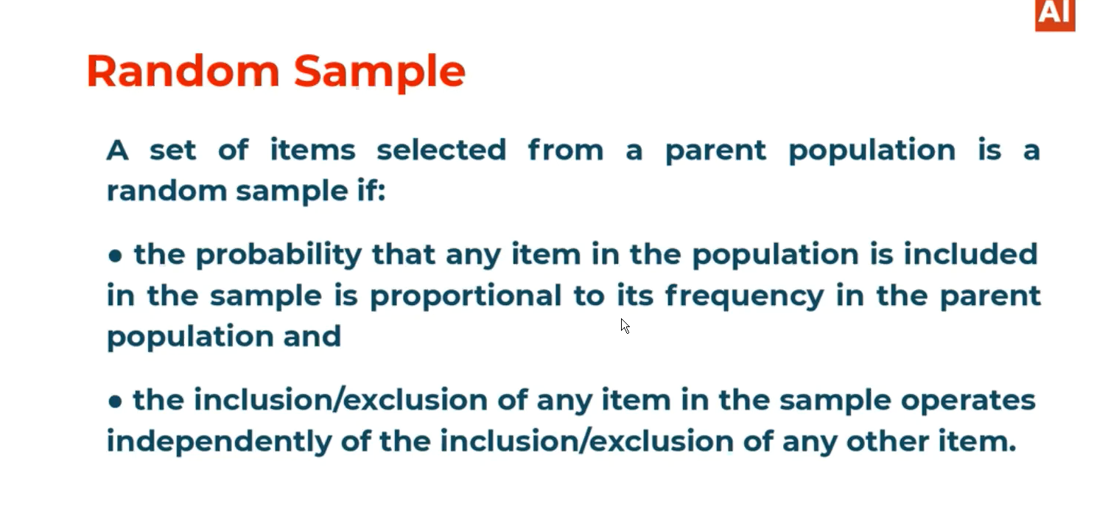

# Random Sample notation:

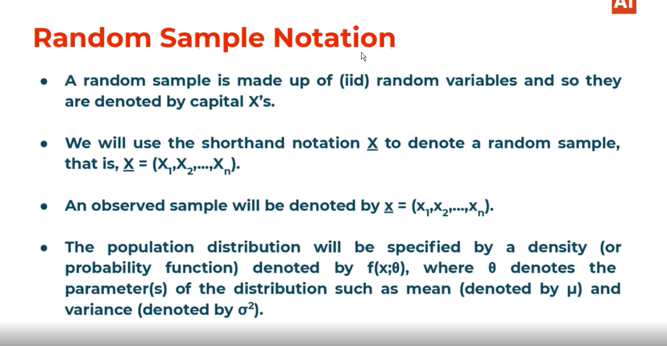

# Sample Random variable Notation and Independent identical distributions:

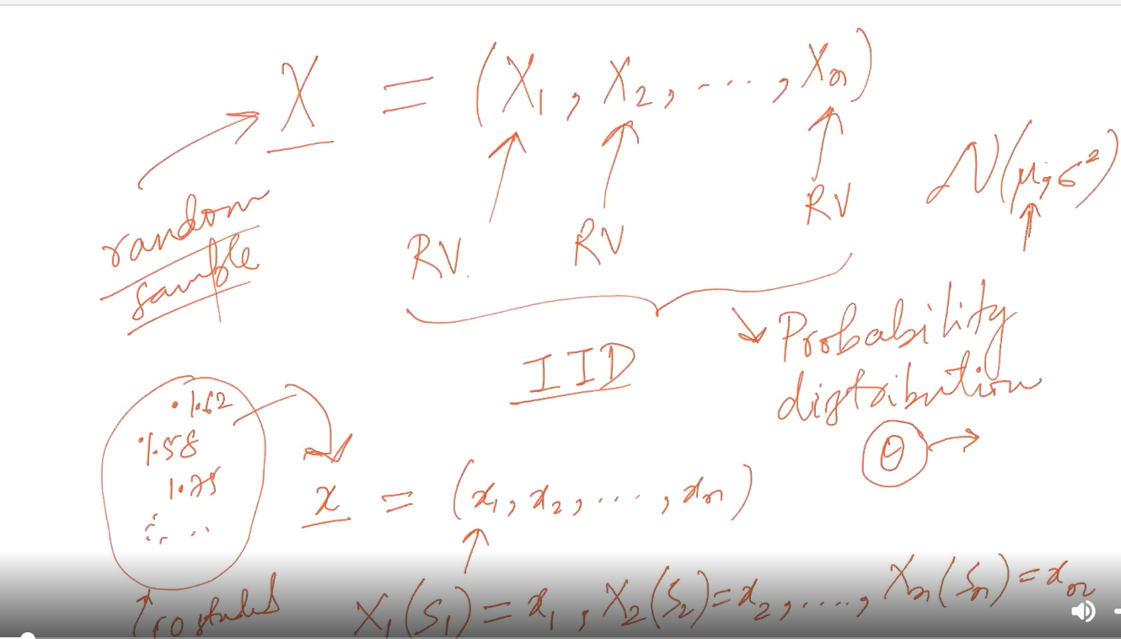

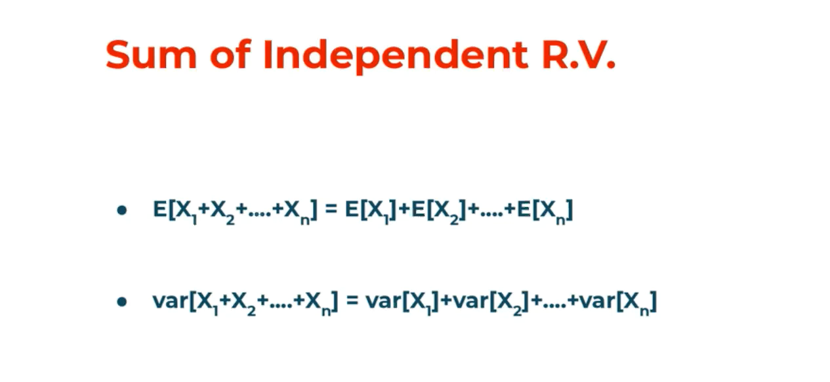

# What Is Statistics:

Function of Random variable is called as statistics.

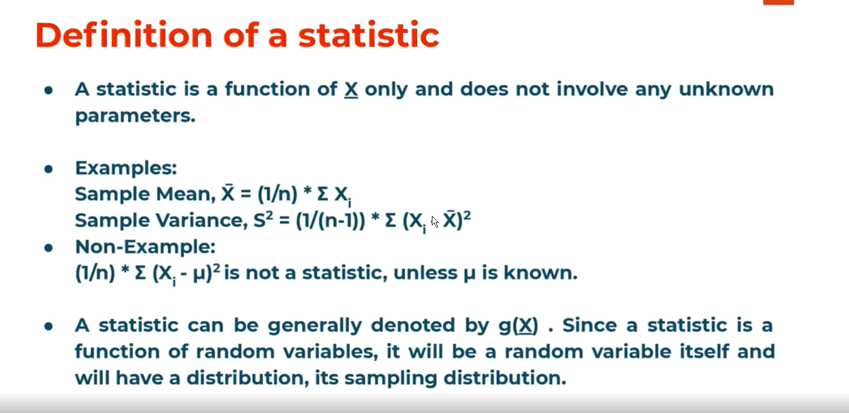

# Population parameters:

These are the parameters from which we can estimate the underlying probability distribution characteristics. Ex: If er talk about normal distribution the population parameter would be meu and sigma because by using them we can judge the distribution is normal distribution or not.

# The sample mean and population mean difference:

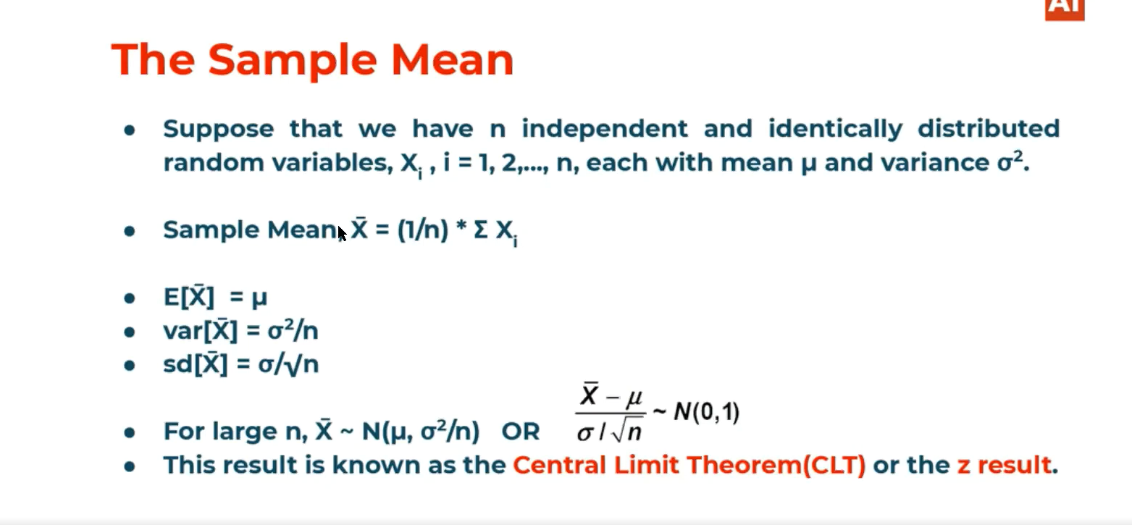

Sample mean is also a random variable, that’s why we apply expectation and variance for Sample.

# Central Limit theorem.

The underlying population distribution maybe anything but if we talk about the sample mean distributions then it should be normal distribution in nature.

The size of the of the sample should be more in ideal case it should be (>30). If the sample size is less then we may not get the normal distributions for the mean of the sample size.

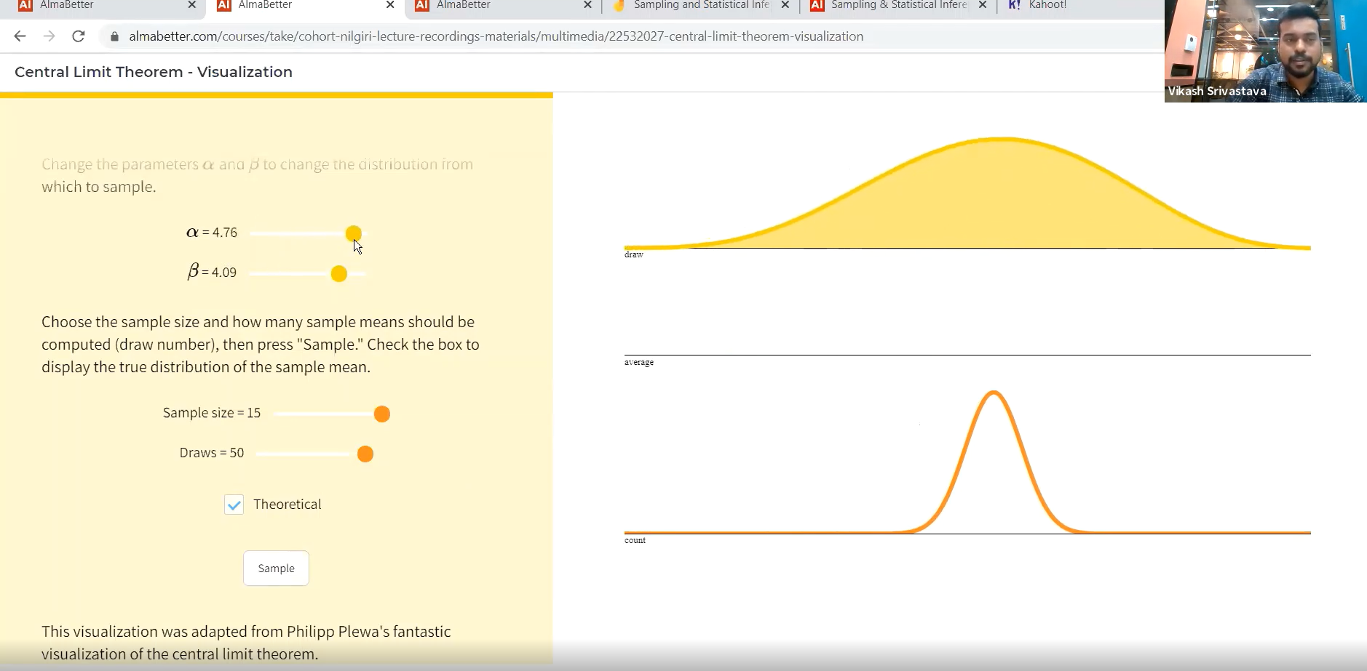

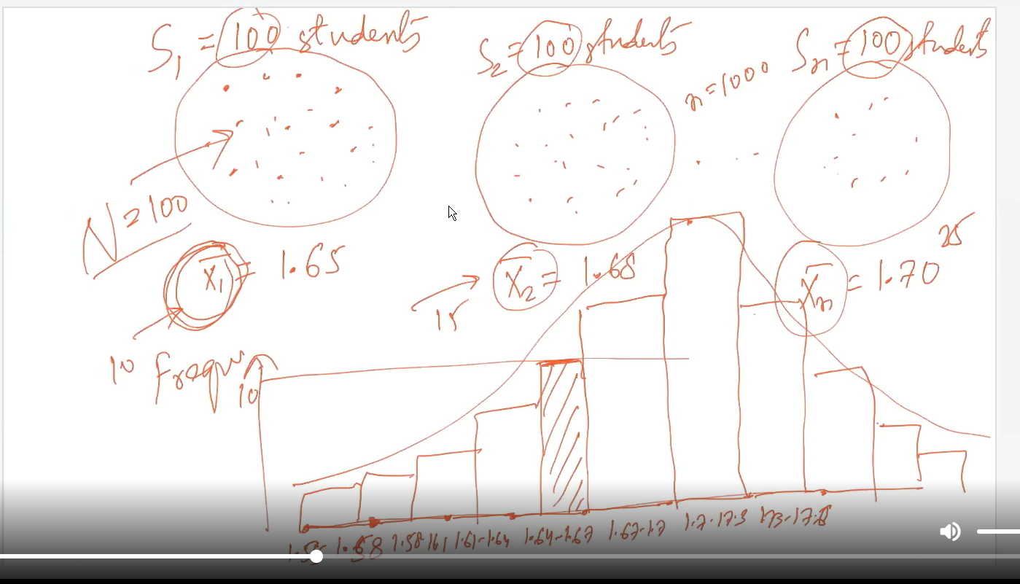

# Variance of random variable and the expected value of random variable:

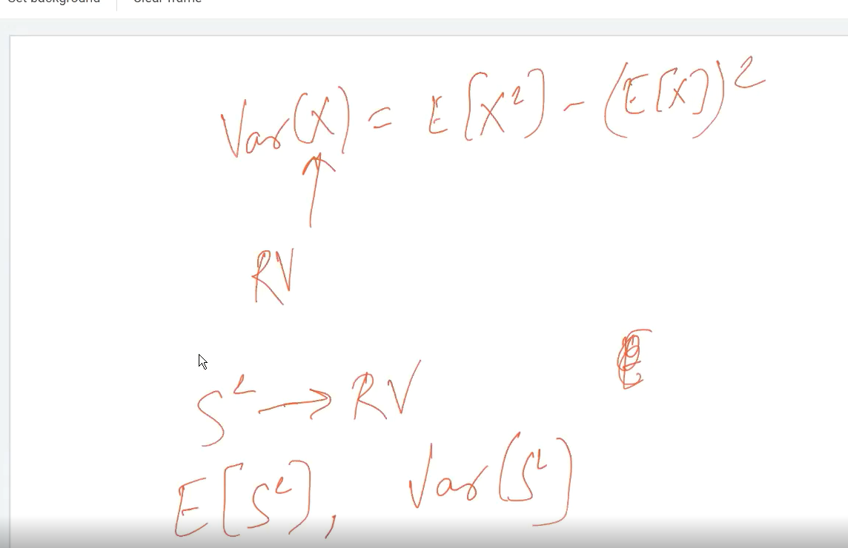

# Note: If the population is normally distributed then for variance, we can use chi square.

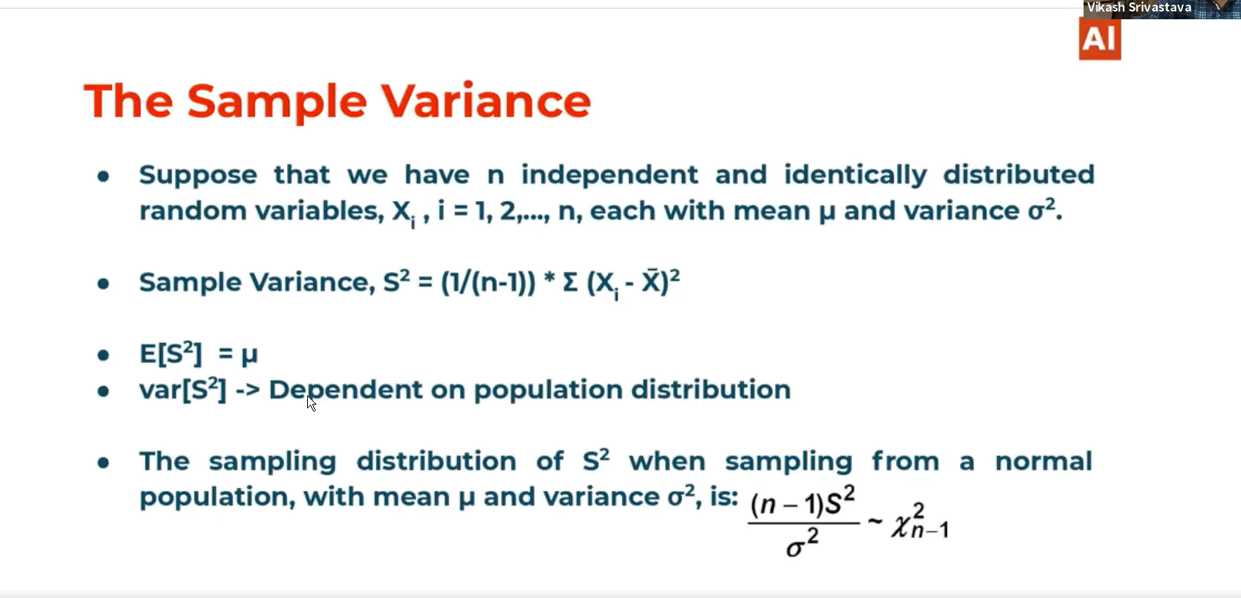

# Point estimation:



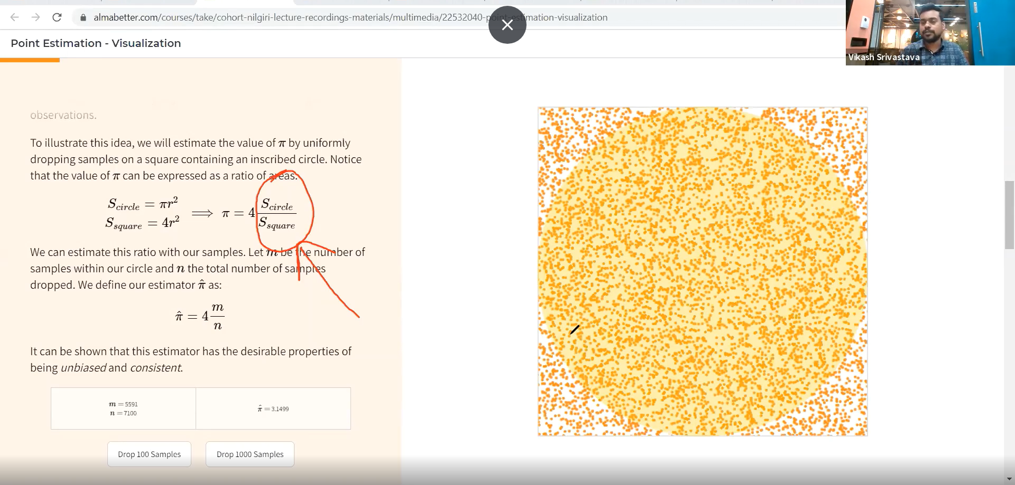

# Methods of moments:

Here we calculate the moments of the sample data and equate it with the population moments which gives the exact value for the moments for population.

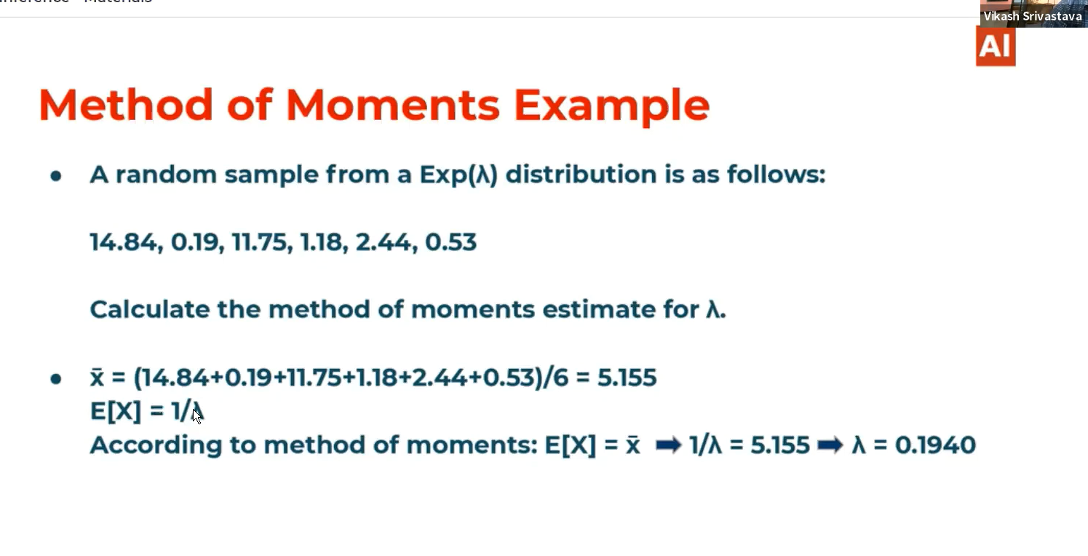

# Methods of maximum likelihood:

This is main when we are expecting the parameter of the population.

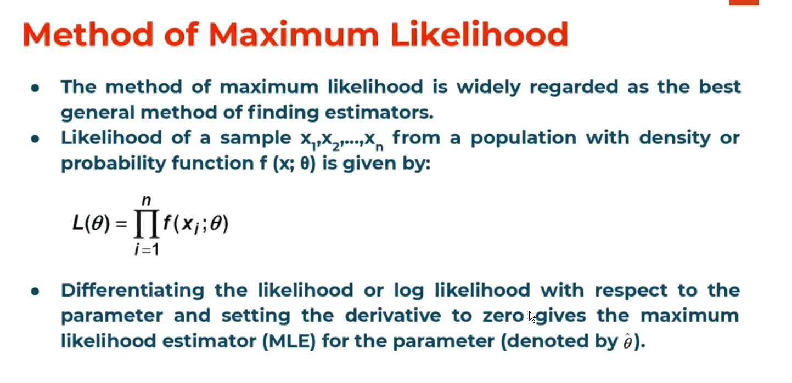

Note: IF the distribution of Population is normally distributed then we can use chi square distribution.